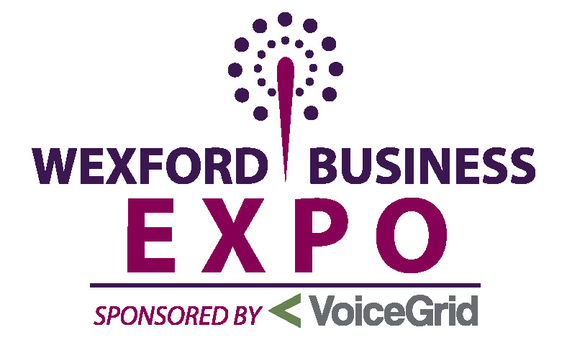

Invite to Exhibit at 2013 Wexford Business EXPO

Dear Sir/Madam,

We invite your company to take full advantage of the opportunity to join us for our 4th annual EXPO. Businesses from all over County Wexford will exhibit at the South East’s largest tradeshow, Wexford Business EXPO, taking place on Thursday, 10th October in Whites of Wexford from 2.00 pm – 8 pm. The tradeshow will see over 80 exhibitors celebrate the richness, quality, diversity and choice of businesses in Co. Wexford.

This tradeshow is a great opportunity for business owners in Co. Wexford to
showcase their products and services to the local community, both commercial
and domestic. Each exhibitor will be allocated an exhibition stand which will have
lighting and table in place.

The EXPO, organised by Wexford Chamber, with support from media partner, The Irish Times, will provide an affordable platform for businesses to meet new prospects, generate leads and new customers, network and learn about new products and services.

The EXPO will be open to the public from 2 pm but pre EXPO seminars will run from 11.30 through to 1 o’clock. These are FREE and open to all business people.

The Expo is free of charge. Live radio broadcasts will ensure great publicity for the event and a post event wine and cheese get together will give everybody the opportunity to reengage and develop meaningful business relationships.
Exhibitors who book before Friday, 20th September can avail of the early bird rates on exhibition space and will be entered into an exclusive draw to win €1000 of advertising with The Irish Times.
There are 80 stands available. You will find enclosed the floor plan and stand prices.
Marketing experts the world over agree that people buy from people they know. In the digital world we now live in, exhibitions provide businesses with a unique marketing advantage – the opportunity to meet, connect and build rapport with current and prospective customers.

WHY?
Please turn over….
Exhibitors
80+ Exhibitors offering advice and the most competitive products
Exhibiting is one of the most efficient, effective and successful marketing tools available to you. Well-chosen and executed events targeted at a specific audience are a key component of the marketing mix providing a focal point for businesses wishing to showcase a new product or service, increase market share and most importantly shorten the sales cycle significantly putting you miles ahead of competitors.
No other form of marketing can give you the opportunity to interact face to face with hundreds of potential new customers actively looking for suppliers, information and guidance on starting or expanding a business or developing your business in Wexford.
If you supply products or services to new and emerging businesses you need to exhibit at the Wexford Business Expo.
Opportunity to introduce new products
Show the marketplace that you are improving your business, consider upsizing your stand size & customise your stand into direct selling and relationship building areas attract potential clients to your booth with good signage and displays.

To book your stand for the South East’s largest Business EXPO contact Wexford Chamber on 053-9122226 or email sales@wexfordchamber.ie

We look forward to seeing you at the annual Wexford Business EXPO.

Yours sincerely,
Wexford Chamber Team
053 9122226 / sales@wexfordchamber.ie
www.wexfordchamber.ie

